Goals for today’s meeting:

* Adding a second motor for the arm to support the weight of a mobile goal
* Making the claw on the arm grasp onto mobile goals
* Making a clamp that can drag mobile goals
* Testing the Inertia Sensor for the programming skills challenge and autonomous period using the Moby Robots
* Testing the GPS Sensor for the programming skills challenge using the Moby Robots
* Develop game strategies during the driver-controlled period

Today, Andrew, Cyrus, Jayla, and Kaitlyn attended.

Our competition at Richmond on February 19 was canceled due to COVID. Meaning, our only competition is on February 6. This was the only competition we were competing at that featured a qualification for states for the robot skills champion. Therefore, we will need to work extra hard to qualify for states in our competition on February 6.

We planned for transportation arrangements for our competition on February 6. The members that will be going will be Andrew, Cyrus, and Kaitlyn. Kaitlyn will be our driver and Andrew will be her spotter. All three members will be driving to the competition separately. We will meet on the day of the competition.

The motors of the Moby Green robot were falling apart. Therefore, they needed to be tightened. We could also add zip ties to hold the motors onto the chassis. However, we only had the 4” zip ties and not a larger size to hold the motors. We needed to order the zipties.

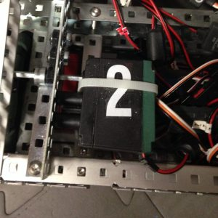

Photo of motors being zip-tied (SUPERRENEGADE, 2018)

Cyrus added a second motor to the arms.

**Blam Bot Claw**

Identify Problem: Cyrus worked on the claw for the robot. He was able to make the robot pick up a mobile goal. However, once picked up, the robot would randomly let go of the mobile goal. He believed that the weight of the mobile goal made the arm open.

**[Insert photo of claw of arm]**

Brainstorm Solutions:

1. Set the brake type of the motors to hold.
2. Set the brake type of the motors to brake.
3. Set the brake type of the motors or coast.
4. If a motor turns unintentionally due to the weight of the mobile goal, move the motor back to its original position
5. Use the tension of the rubber bands to keep the claw together

Select the Best Solution: Cyrus chose to use the third solution: set the brake type to hold. This would force the motors to stay in its position and if the weight of the mobile goal were to open the claw, the motors would close it back up.

Build and Program the Solution: Cyrus worked on setting the brake type of the motors to hold

**Sensors**

Andrew started working on the inertia sensor. He attached it to the Moby Green robot and experimented with its movement. Its distance was more accurate than without it, but not reliable. However, its rotation was reliably accurate.

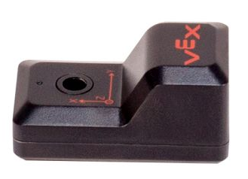

The inertia sensor has an accelerometer, measuring the acceleration of the robot; and a gyroscope, measuring the rotation of the robot. Adding an inertia sensor to the drivetrain allows the robot to move and rotate accurate and precise amounts. For example, when the robot moves forward by 1 foot, the inertia sensor will measure how much the robot has accelerated to measure how long the robot needs to continue moving forward for before reaching 1 foot. If the robot rotates 90 degrees to the left, the inertia sensor will measure how much the robot has already rotated and measure how long it needs to continue rotating before reaching 45 degrees.

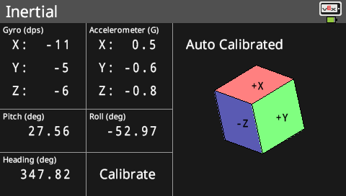

In our next meeting, Andrew plans on running multiple tests to determine how accurate and precise the robot’s inertia sensor was. He also plans on testing the GPS sensor and determine if it is more reliable than the inertia sensor.

Citations

SUPERRENEGADE. “Zip-Tie Those Motors.” Renegade Robotics, 19 Feb. 2018, https://renegaderobotics.org/zip-tie-motors/.